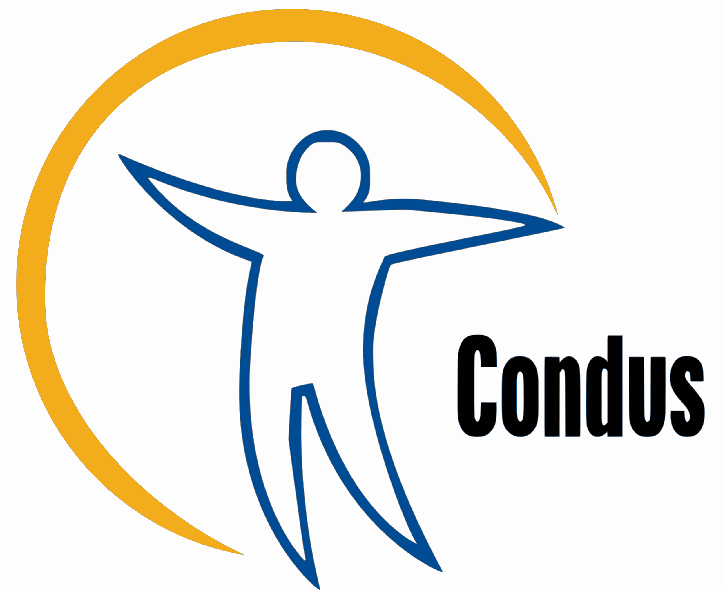
Ease-of-access in Condus ry’s and Condus’ member organisations’ mostly used premises:

Using or copying from this document to your own event description is allowed.

Gustavus Rex is situated on the first floor of the Leppätalo building (Leppäsuonkatu 11). The front door has a slight threshold, which may be problematic to wheelchair access. The premises has one accessible toilet and two other toilets, all of which are gender-neutral. The premises has no artificial smoke machines nor any flashing lights. Assistant- or guide dogs are allowed on the premises.
If you have any questions or wishes related to ease-of-access regarding this premises, please contact this email address.
Conddoori is located within the Minerva-building (Siltavuorenpenger 5) on the K2-floor. It is possible to gain access through the rear entrance of the Minerva-building or via elevator for wheelchair access. The rear entrance has a threshold. The elevator control panel has Braille -lettering. The premises has one gender neutral toilet and an accessible toilet on the same floor of the building. There is no smoke machine or flashing lights within the premises.
If you have any questions or wishes related to ease-of-access regarding this premises,
please contact this email address.
Alina-Hall is located on the third floor of New Student House at Mannerheimintie 5A. The premises has no wheelchair access, the only way of access is via a staircase. The premises has a wheelchair available for use and a induction loop on site. There is an accessible toilet within the premises. Smoke machines are forbidden in Alina-Hall, but the premises might have flashing lights.

If you have any questions or wishes related to ease-of-access regarding this premises, please contact this email address.

Roof Top Sauna Sivistys is located on the top floor of the Leppätalo (Domus Gaudium) building (Leppäsuonkatu 11). It has wheelchair access via elevator. There is an accessible toilet within the premises. There is no smoke machines or flashing lights within the premises.

If you have any questions or wishes related to ease-of-access regarding this premises,
please contact this email address.

When describing an event, it is advisable to mention the following things regarding ease-of-access:
- Is the event non-alcoholic or will there be alcohol?
- Is it possible to arrive/leave halfway through the event? Is speaking out loud/participation
expected during the event?
- Can a friend be brought along to the event? Is the event family friendly?
- Are safe space protocols in use at this event? Is there a safety person (if yes,
how can he/she be identified)? Is it possible to leave anonymous feedback?
-What language is the event? Is it possible to attend the event with a different
language then Finnish?

If you or your student organisation have something to add or suggestions to the list, please contact us per e-mail: yhdenvertaisuus@condus.fi.

